3/13/2025

Riphah International University

**Name:** Ayesha Tayyaba

**SAP ID:** 56546

**Department:** CS

Lab:05

COAL

**Task: 01**

.model small

.stack 100h

.data

prompt db 'Enter a two-digit number: $'

result_msg db 'The reversed number is: $'

newline db 0x0A, 0x0D, '$'

num1 db 0

num2 db 0

.code

main:

mov ax, @data

mov ds, ax

mov es, ax

; Display prompt

lea dx, prompt

mov ah, 09h

int 21h

; Get first digit

mov ah, 01h

int 21h

mov num1, al ; Store first digit

; Get second digit

mov ah, 01h

int 21h

mov num2, al ; Store second digit

; Display result message

lea dx, result_msg

mov ah, 09h

int 21h

; Display the second digit first (Reversing)

mov dl, num2

mov ah, 02h

int 21h

; Display the first digit second (Reversing)

mov dl, num1

mov ah, 02h

int 21h

; Print newline

lea dx, newline

mov ah, 09h

int 21h

; Exit program

mov ah, 4Ch

int 21h

end main

**OUTPUT:**

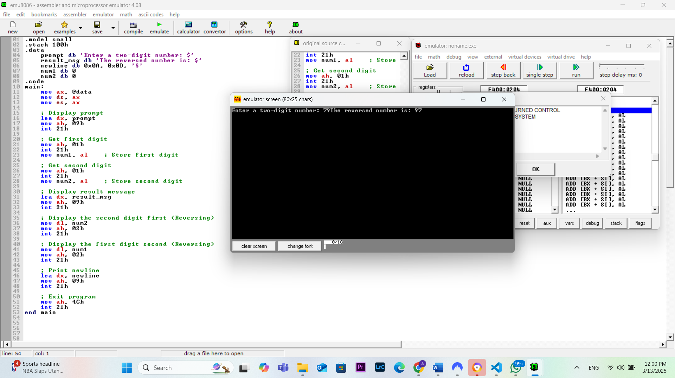

**Task:03**

.model small

.stack 100h

.data

result_msg db 'The result is: $'

result db ? ; To store the final result

newline db 0Dh, 0Ah, '$'

.code

main:

mov ax, @data ; Initialize data segment

mov ds, ax

mov es, ax

; Evaluate 3 + 5 - 6

mov al, 3 ; Load 3 into AL

add al, 5 ; Add 5 (AL = 3 + 5 = 8)

sub al, 6 ; Subtract 6 (AL = 8 - 6 = 2)

mov result, al ; Store the result in 'result'

; Display result message

lea dx, result_msg

mov ah, 09h

int 21h

; Display the result

mov al, result

add al, 30h ; Convert number to ASCII

mov dl, al

mov ah, 02h

int 21h

; Print newline

lea dx, newline

mov ah, 09h

int 21h

; Exit program

mov ah, 4Ch

int 21h

end main

**OUTPUT:**

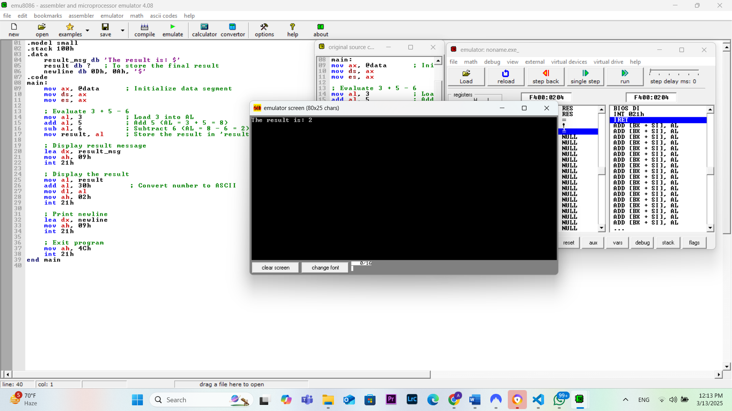

**Task: 04**

.model small

.stack 100h

.data

prompt1 db 'Enter first single-digit number: $'

prompt2 db 0Dh, 0Ah, 'Enter second single-digit number: $'

result_msg db 0Dh, 0Ah, 'After swapping: $'

newline db 0Dh, 0Ah, '$'

.code

main:

mov ax, @data ; Initialize data segment

mov ds, ax

mov es, ax

; Get first number from user

lea dx, prompt1

mov ah, 09h

int 21h

mov ah, 01h ; Read single character input

int 21h

sub al, 30h ; Convert ASCII to integer

mov bl, al ; Store first number in BL

; Get second number from user

lea dx, prompt2

mov ah, 09h

int 21h

mov ah, 01h ; Read single character input

int 21h

sub al, 30h ; Convert ASCII to integer

mov bh, al ; Store second number in BH

; Swap the values

xchg bl, bh

; Display result message

lea dx, result_msg

mov ah, 09h

int 21h

; Display swapped numbers

mov al, bl

add al, 30h ; Convert to ASCII

mov dl, al

mov ah, 02h

int 21h

mov dl, ' ' ; Display space

mov ah, 02h

int 21h

mov al, bh

add al, 30h ; Convert to ASCII

mov dl, al

mov ah, 02h

int 21h

; Print newline

lea dx, newline

mov ah, 09h

int 21h

; Exit program

mov ah, 4Ch

int 21h

end main

**OUTPUT:**

